LAB SUBMISSION – 7 <-link

# Meher Shrishti Nigam – 20BRS1193

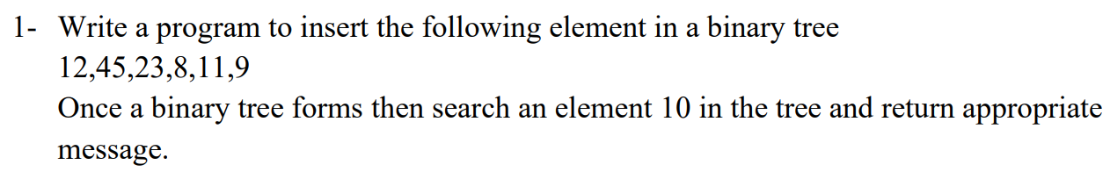

#include <stdio.h>

#include <stdlib.h>

#include <limits.h>

typedef struct Node{

    int data;

    struct Node * left;

    struct Node * right;

}Node;

typedef struct BinaryTree{

    Node * root;

}BinaryTree;

Node * createNode(int *item*)

{

    Node * temp = (Node *)malloc(sizeof(Node));

    temp->data = item;

    temp->left = NULL;

    temp->right = NULL;

    return temp;

}

*/\**

*\*  Creates a binary tree structure with one node. Root pointer points to that node.*

*\*/*

BinaryTree * createBinaryTree(int *item*)

{

    BinaryTree * bt = (BinaryTree *)malloc(sizeof(BinaryTree));

    Node * newnode = createNode(item);

    bt->root = newnode;

    return bt;

}

*/\**

*\* Inserts node at left of the node specified unless node is already present.*

*\*/*

void insertAtLeft(Node * *root*, int *item*)

{

    Node * newnode = createNode(item);

    if(root->left == NULL)

        root->left = newnode;

    else

        printf("Left node already occupied.\n");

}

*/\**

*\* Inserts node at right of the node specified unless node is already present.*

*\*/*

void insertAtRight(Node * *root*, int *item*)

{

    Node * newnode = createNode(item);

    if(root->right == NULL)

        root->right = newnode;

    else

        printf("Right node already occupied.\n");

}

int is_found = 0;

void search(int *item*, Node * *root*)

{

    if(root == NULL)

        return;

    if(root->data == item)

    {

        printf("Item %d was found.\n", item);

        is_found = 1;

        return;

    }

    search(item, root->left);

    search(item, root->right);

}

int main()

{

    BinaryTree * bt = createBinaryTree(12);

    insertAtLeft(bt->root, 45);

    insertAtLeft(bt->root->left, 23);

    insertAtRight(bt->root, 8);

    insertAtRight(bt->root->left, 11);

    insertAtRight(bt->root->right, 9);

    is_found = 0;

    search(10, bt->root);

    if(is_found == 0)

        printf("Item was not found.\n");

}



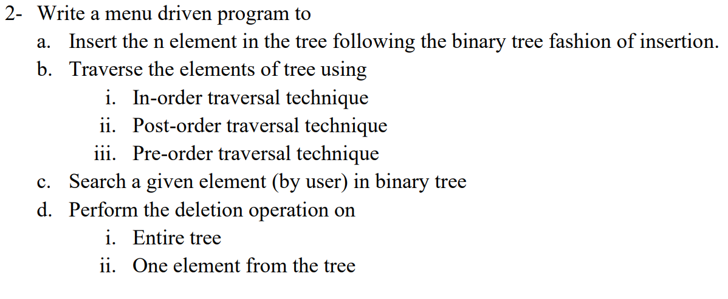

#include <stdio.h>

#include <stdlib.h>

#include <limits.h>

typedef struct Node{

    int data;

    struct Node * left;

    struct Node * right;

}Node;

typedef struct BinaryTree{

    Node * root;

}BinaryTree;

Node * createNode(int *item*)

{

    Node * temp = (Node *)malloc(sizeof(Node));

    temp->data = item;

    temp->left = NULL;

    temp->right = NULL;

    return temp;

}

*/\**

*\*  Creates a binary tree structure with one node. Root pointer points to that node.*

*\*/*

BinaryTree * createBinaryTree(int *item*)

{

    BinaryTree * bt = (BinaryTree *)malloc(sizeof(BinaryTree));

    Node * newnode = createNode(item);

    bt->root = newnode;

    return bt;

}

*/\**

*\* Inserts node at left of the node specified unless node is already present.*

*\*/*

void insertAtLeft(Node * *root*, int *item*)

{

    Node * newnode = createNode(item);

    if(root->left == NULL)

        root->left = newnode;

    else

        printf("Left node already occupied.\n");

}

*/\**

*\* Inserts node at right of the node specified unless node is already present.*

*\*/*

void insertAtRight(Node * *root*, int *item*)

{

    Node * newnode = createNode(item);

    if(root->right == NULL)

        root->right = newnode;

    else

        printf("Right node already occupied.\n");

}

void InorderTraversal(Node * *root*)

{

    if(root != NULL)

    {

        InorderTraversal(root->left);

        printf("%d ",root->data);

        InorderTraversal(root->right);

    }

}

void PreorderTraversal(Node * *root*)

{

    if(root != NULL)

    {

        printf("%d ",root->data);

        PreorderTraversal(root->left);

        PreorderTraversal(root->right);

    }

}

void PostorderTraversal(Node * *root*)

{

    if(root != NULL)

    {

        PostorderTraversal(root->left);

        PostorderTraversal(root->right);

        printf("%d ",root->data);

    }

}

void deleteBinaryTree(Node * *root*)

{

    Node * temp = root;

    if(root != NULL)

    {

        deleteBinaryTree(root->left);

        deleteBinaryTree(root->right);

    }

    free(temp);

}

*// Deletes elements using the node of the element to be delted and its parent node.*

void deleteNode(Node * *root*, Node * *parent*)

{

*// If 0 child*

    if(root->left == NULL && root->right == NULL)

    {

        if(root == parent->right)

            parent->right = NULL;

        else if(root == parent->left)

            parent->left = NULL;

        free(root);

        printf("The node had 0 children and now has been deleted.\n");

        return;

    }

*// If 1 child*

    if(root->left != NULL && root->right == NULL)

    {

        if(root == parent->right)

            parent->right = root->left;

        else if(root == parent->left)

            parent->left = root->left;

        printf("The node had 1 child and now has been deleted.\n");

        free(root);

        return;

    }

    if(root->left == NULL && root->right != NULL)

    {

        if(root == parent->right)

            parent->right = root->right;

        else if(root == parent->left)

            parent->left = root->right;

        free(root);

        return;

    }

*// If 2 child - we delete the rightmost deepest node from root after exchanging the data in the rightmost deepest node from root and the node to be deleted*

    Node * temp = root;

    Node * temp2 = parent;

    while(temp->right != NULL)

    {

        temp = temp->right;

        temp2 = temp2->right;

    }

    root->data = temp->data;

    temp2->right = NULL;

    printf("The node had 2 children and now has been deleted.\n");

    free(temp);

}

int is_found = 0;

void search(int *item*, Node * *root*)

{

    if(root == NULL)

        return;

    if(root->data == item)

    {

        printf("Item %d was found.\n", item);

        is_found = 1;

        return;

    }

    search(item, root->left);

    search(item, root->right);

}

int main()

{

    BinaryTree * bt = createBinaryTree(12);

    insertAtLeft(bt->root, 45);

    insertAtLeft(bt->root->left, 23);

    insertAtRight(bt->root, 8);

    insertAtRight(bt->root->right, 11);

    insertAtLeft(bt->root->right, 9);

    insertAtRight(bt->root->right->right, 101);

    insertAtLeft(bt->root->right->right, 1);

    insertAtRight(bt->root->right->left, 7);

    insertAtLeft(bt->root->right->left, 65);

*// Searching in the binary tree*

    is_found = 0;

    search(10, bt->root);

    if(is_found == 0)

        printf("Item was not found.\n");

        is_found = 0;

    search(1, bt->root);

    if(is_found == 0)

        printf("Item was not found.\n");

*// Inorder, Preorder and Postorder traversals of the binary tree*

    InorderTraversal(bt->root);

    printf("\n");

    PreorderTraversal(bt->root);

    printf("\n");

    PostorderTraversal(bt->root);

    printf("\n");

*// 0 child deletion*

    deleteNode(bt->root->right->right->right, bt->root->right->right);

    InorderTraversal(bt->root);

    printf("\n");

*// 1 child deletion*

    deleteNode(bt->root->right->right, bt->root->right);

    InorderTraversal(bt->root);

    printf("\n");

*// 2 child deletion*

    deleteNode(bt->root->right, bt->root);

    InorderTraversal(bt->root);

    printf("\n");

*// deletion of whole binary tree*

    deleteBinaryTree(bt->root);

    InorderTraversal(bt->root);

    printf("\n");

}

The binary tree formed looks like –

